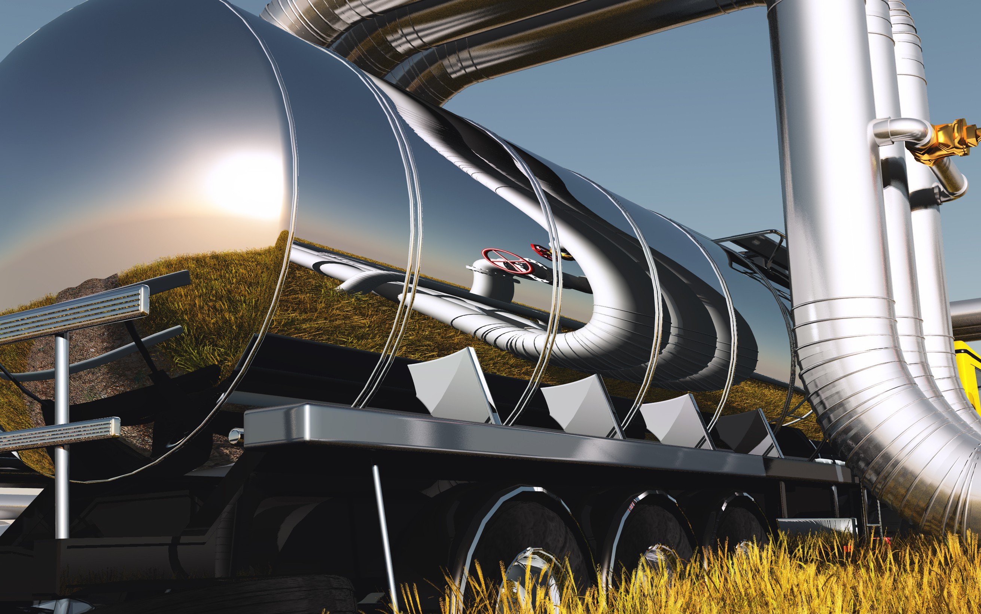

ASSESSMENT OF SOLID AND
LIQUID FUEL QUALITY

SERVICES
Comprehensive evaluation of material properties and processed products, including:
• measurement of calorific value,
• determination of total carbon and moisture content,
• elemental analysis of organic and inorganic carbon, nitrogen, hydrogen, and sulfur,
• analysis of moisture, ignition loss, and volatile matter.
Our studies cover samples of diverse origin, such as hard and brown coal, anthracite, coke, biomass for energy purposes, waste (including SRF – Solid Recovered Fuels), as well as activated carbons and other porous materials.


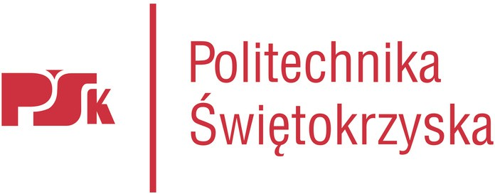
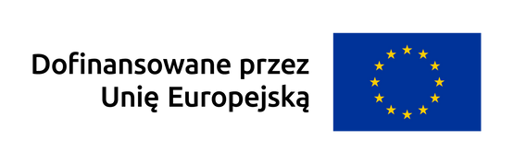



KONTAKT BROKER TECHNOLOGII:
mfudala@tu.kielce.pl tel. (+48) 785 370 445
www.kampus.gum.gov.pl ott.tu.kielce.pl

RECIPIENTS

- companies engaged in the extraction, production,
and utilization of fuels,
- enterprises from the energy, heating, mining,
and chemical industries,
- entities operating in the areas of recovery, recycling,
and waste management,
- research and scientific institutions conducting
specialized laboratory analyses in the field of
fuel characterization and combustion product assessment.

BENEFITS OF COOPERATION

- Reliable and consistent testing,
- combined with expert support in developing and optimizing innovative quality control solutions for raw materials and processed products.

